**USER MANUAL**

**Installation**

There are 3 main components required to run the project code:

* Python 3.x
* Matplotlib
* NetworkX

Python can be downloaded from: <https://www.python.org/downloads/>

Download the latest version of Python 3.x based on your system Operating System.

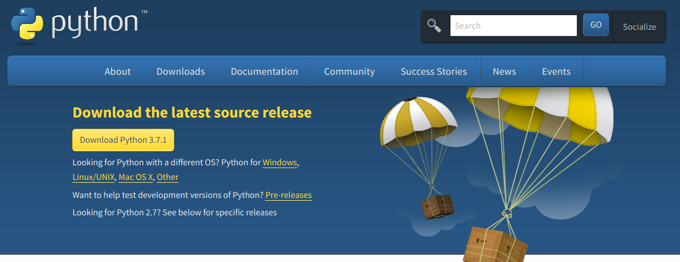

Python includes the PIP installer which can be used to install the other 2 libraries.

For Windows machines you have to make sure to add your python directory the PATH environment variable if the python installer does not do it automatically. Directories should be separated by a semicolon.

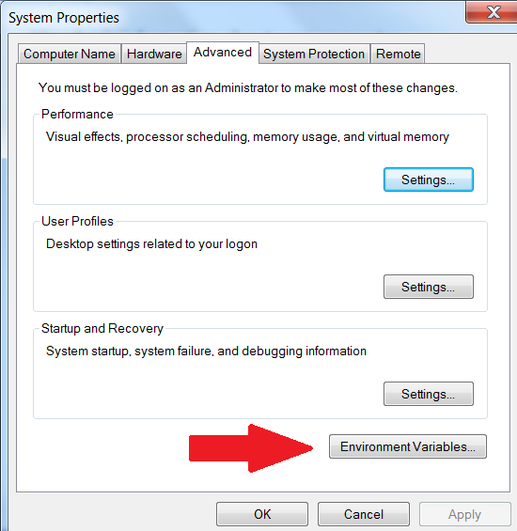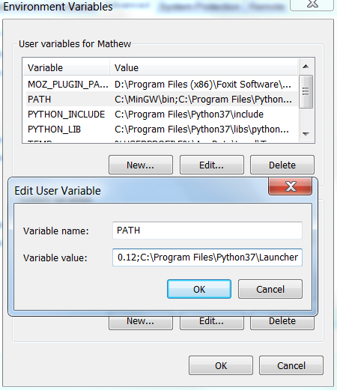

Matplotlib can be installed following the instruction on: <https://matplotlib.org/users/installing.html>

python -m pip install -U pip  
python -m pip install -U matplotlib

NetworkX can be installed following the instructions on: <https://networkx.github.io/documentation/stable/install.html>

$ pip install networkx

**Running Instructions**

To run the program navigate to /Multi-Vehicle_Patrolling directory. Then run the following command with arguments for ground (-g), air (-a), or sea (-s). 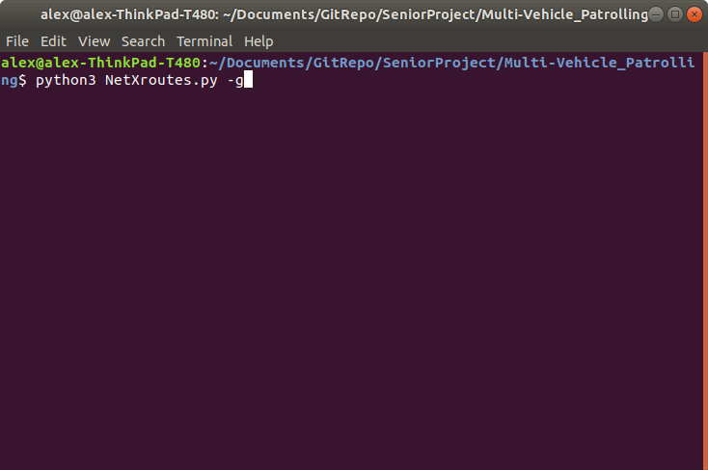

On Linux: python3 NetXroutes.py [-g, -a, -s]

On Windows: py NetXroutes.py [-g, -a, -s]